Name: Final Exam-A Math 4371

Key

1. Consider the polynomial: 

2

1. How many roots does the polynomial have?

2

1. How many real roots does the polynomial have?

0

1. How many complex roots does the polynomial have?

2

1. How many *x*-intercepts does the polynomial have?
2. Factor the polynomial completely into irreducible polynomials (over the reals):



1. Copy a graph of the polynomial (from a CAS into the textbox below) which clearly shows the behavior of the polynomial near the roots (if any) and near any local minimums or maximums (if any).

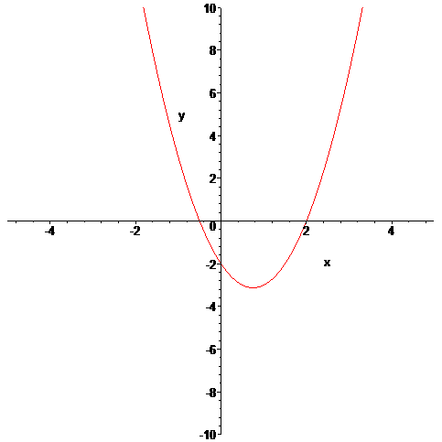

1. Consider the polynomial: 

1

2

1

3

1. How many roots does the polynomial have?

1. How many real roots does the polynomial have?
2. How many complex roots does the polynomial have?
3. How many *x*-intercepts does the polynomial have?
4. Factor the polynomial completely into irreducible polynomials (over the reals):



1. Copy a graph of the polynomial (from a CAS into the textbox below) which clearly shows the behavior of the polynomial near the roots (if any) and near any local minimums or maximums (if any).

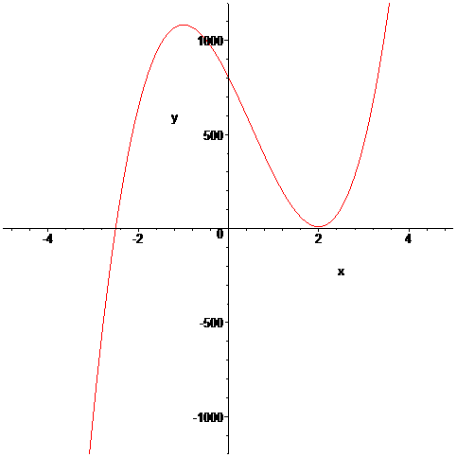

1. Consider the polynomial: 

4

0

4

4

1. How many roots does the polynomial have?

1. How many real roots does the polynomial have?
2. How many complex roots does the polynomial have?

1. How many *x*-intercepts does the polynomial have?
2. Factor the polynomial completely into irreducible polynomials (over the reals):



1. Copy a graph of the polynomial (from a CAS into the textbox below) which clearly shows the behavior of the polynomial near the roots (if any) and near any local minimums or maximums (if any).

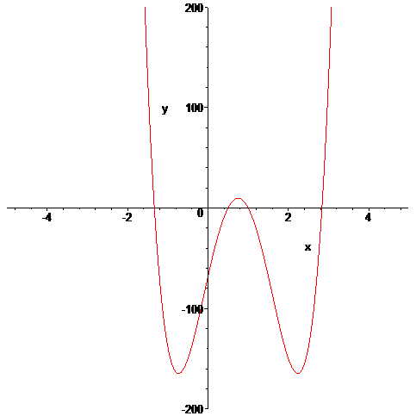

1. Consider the set 
2. Find a polynomial whose roots are exactly the elements of the set . Write the polynomial out in expanded form:



2 distinct or 3 counting multiplicity

1. How many *x*-intercepts does the polynomial have?
2. Copy a graph of the polynomial (from a CAS into the textbox below) which clearly shows the behavior of the polynomial near the roots (if any) and near any local minimums or maximums (if any).

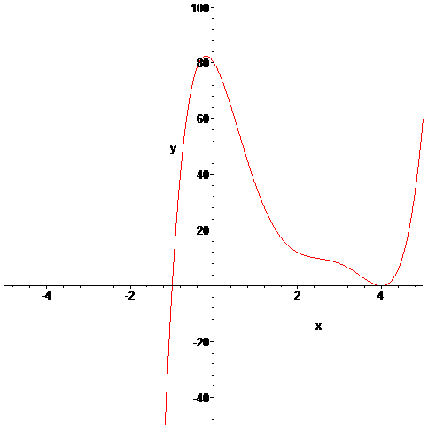

1. Consider the following set of functions:



1. Which of the five functions have only complex roots?

Yes

Yes

y1  y2 y3 y4 y5

1. Estimate the minimum value of each function.

-1

-1.5

-1

.5

3

y1  y2 y3 y4 y5

1. Estimate the *x*-intercepts of those functions for which real roots exist.

-.73, .69

y1 y2  y3

.26, 1.71

-.35, 1.39

y4  y5

1. Using a CAS, plot the graphs all five functions on the same coordinate axes. Copy the plot into the textbox below.

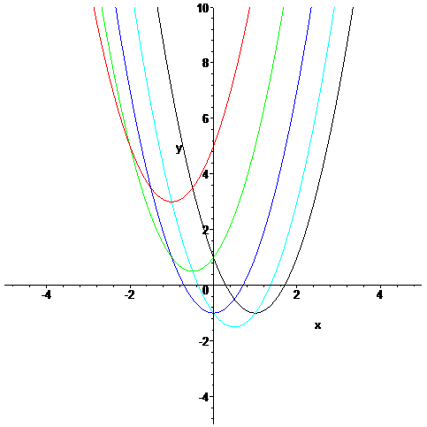

1. Consider the rational function: 
2. Does the function have vertical asymptotes? If so, where?

x=-2, x= 4

Yes

Yes/No Where?

1. Does the function have a horizontal asymptote? If so, where?

y = 2

Yes

Yes/No Where?

1. Does the function have a slant asymptote?

No

Yes/No

1. Copy a graph of the function (from a CAS into the textbox below) which clearly shows the behavior of the function near any intercepts (if any) and also shows the asymptotes (if any).

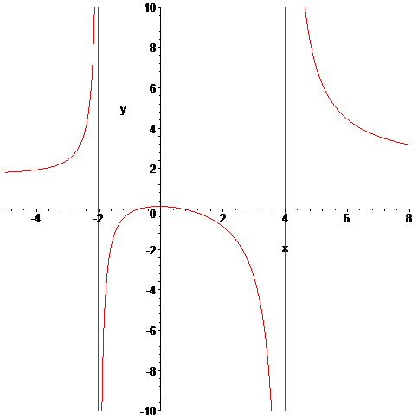

1. Consider the rational function: 
2. Does the function have vertical asymptotes? If so, where?

x=1/2

Yes

Yes/No Where?

1. Does the function have a horizontal asymptote? If so, where?

No

Yes/No Where?

1. Does the function have a slant asymptote?

Yes

Yes/No

1. Copy a graph of the function (from a CAS into the textbox below) which clearly shows the behavior of the function near any intercepts (if any) and also shows the asymptotes (if any).

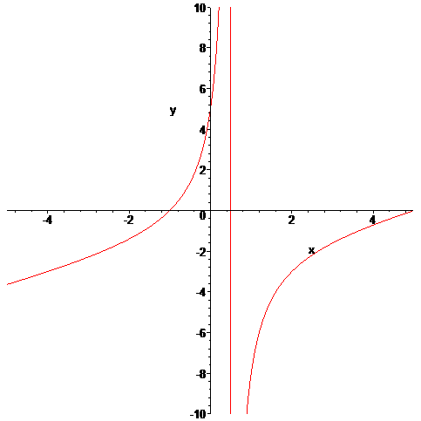

1. Using a CAS construct an implicit plot of the equation . Copy the graph of the equation from the CAS into the textbox below.

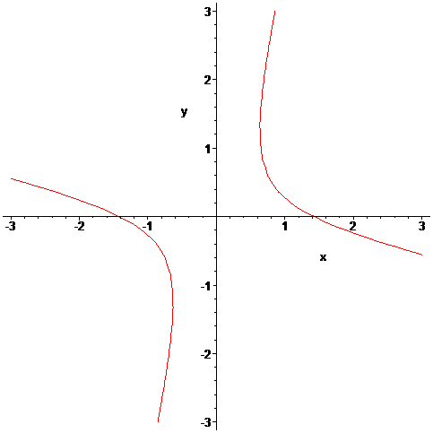

1. Using a CAS construct an plot of the 3-d graph of the function Copy the graph of the function from the CAS into the textbox below.

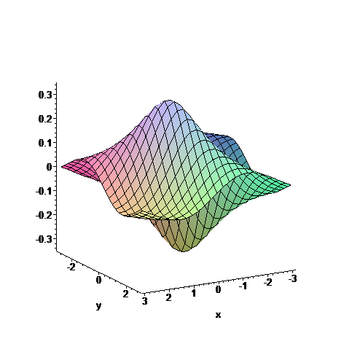

1. For the following sequence identify the next two missing terms and describe the pattern that the terms in the sequence follow.

0

1

{1,0,0,1,0,1,0,1,1,1,0,1,0,1,1,1,0, , , . . . }

Pattern:

1 if n is not prime, 0 if n is prime

1. For the following recursive sequence identify the next two missing terms and describe the pattern that the terms in the sequence follow.

85

171

{1, 1, 3, 5, 11, 21, 43, , , . . . }

Pattern:

An=2\*An-2 + An-1

1. For the following sequence *S* find the specified missing terms. *S* is an arithmetic sequence for which the 6th and 10th terms are 27 and 55, resp.

174

-8

Find the 1st term and the 27th term:  , 

1. For the following sequence *S* find an explicit functional formula for generating all of the terms of the sequence and find the 39th term of the sequence. *S* is the sequence given by

{1, 4, 11, 22, 37, . . . } where the second differences are constant.

An = 2 + (-3)n + 2 n2

2927

Formula: , 

1. On the back of the instruction’s page for the exam, sketch on the same graph the derivative and the anti-derivative of function pictured below.

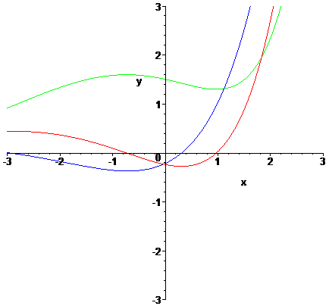

Function = Red Derivative = Blue Anti-Derivative = Green

1. In the picture below the graphs of three functions are plotted on the same coordinate axes. Of the three graphs one is the graph of a function *f* , one is the graph of the derivative of *f* and one is the graph of an anti-derivative of *f*. Identify which graph is which:

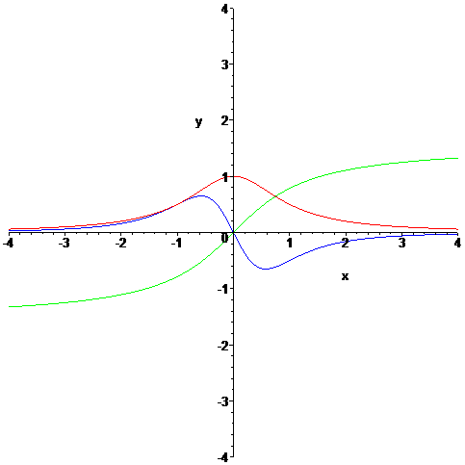

Green

Blue

Red

Function = Derivative = Anti-derivative =